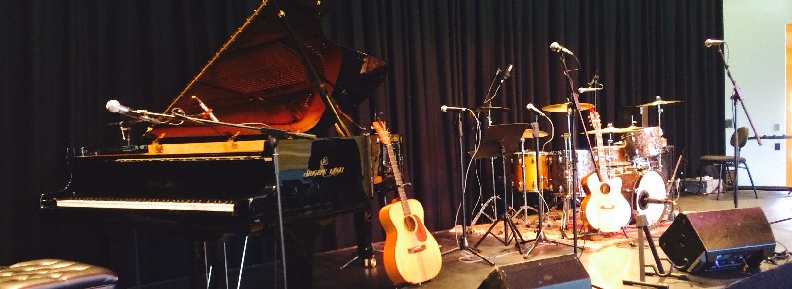
Pete Wild
Bio
Pete Wild’s first piano was rescued from a bulldozer at a demolition site.
He lives on the NSW South Coast in the village of Candelo; reported by the UK Guardian in December 2017 to be one of the most exciting underground music scenes in the world.
There are only 300 people in the town, but it’s more exciting than any city – it’s pure creativity coming out of the bush.
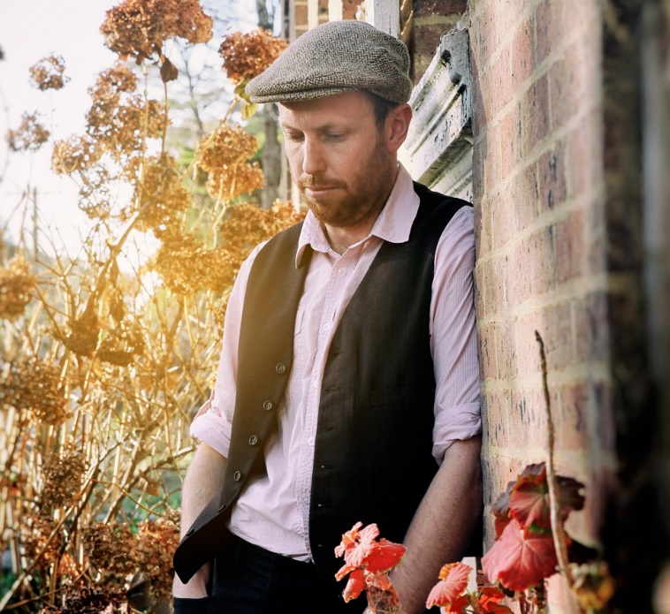
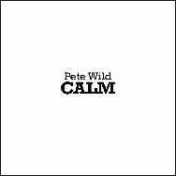
Highly regarded as a performer and songwriter on the NSW South Coast, Pete’s debut self-titled album was featured as album of the week on Radio National.
Combining his theatrical background and idiosyncratic honesty, Pete's performance is deeply compelling as he moves from quirky theatrical absurdities to unexpected poignant and passionate expression.
He has worked closely with several highly regarded Australian musicians, performing and recording with Heath Cullen, Jackie Marshall, Sam Martin (Mikelangelo and the Black Sea Gentlemen), Eamon McNelis (Flap!), Mike Martin (The Strelley Project), Melanie Horsnell, and Kate Burke (Kate Burke & Ruth Hazleton, Trouble in the Kitchen).
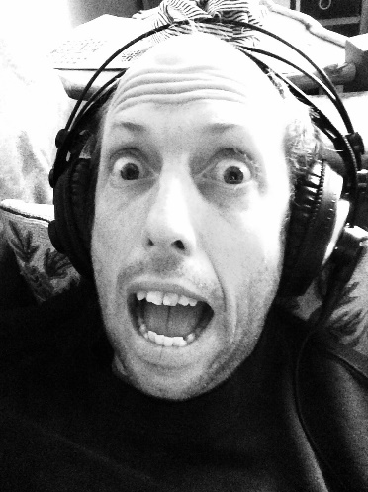
Pete’s freshly pressed 2017 album Calm presents indie-folk pop. A collection of vibrant vignettes which read as a survival manual for contemporary small-town country Australia; caravan renovations, insomnia-inducing anxiety, romantic beginnings on South Coast beaches, losing your lover to the Mars 1 colonisation project...

PO Box 4102
Candelo
NSW 2550
AUSTRALIA
+61 410 016 562

CONTACT:
pete@petewild.com.au
petewild.com.au
facebook.com/petewildmusic
twitter.com/PeteWildMusic

